**Ideation Phase**

**Brainstorm & Idea Prioritization Template**

|  |  |
| --- | --- |
| Date | 19 OCT 2023 |
| Team ID | 65E0353633A52479B794D3E79D1542E1 |
| Project Name | DATA DOMINATORS:A COMPARATIVE STUDY OF TOP GLOBAL UNIVERSITIES IN DATA ANALYTICS |
| Maximum Marks | 4 Marks |

**Brainstorm & Idea Prioritization Template:**

**Step-1: Team Gathering, Collaboration and Select the Problem Statement**

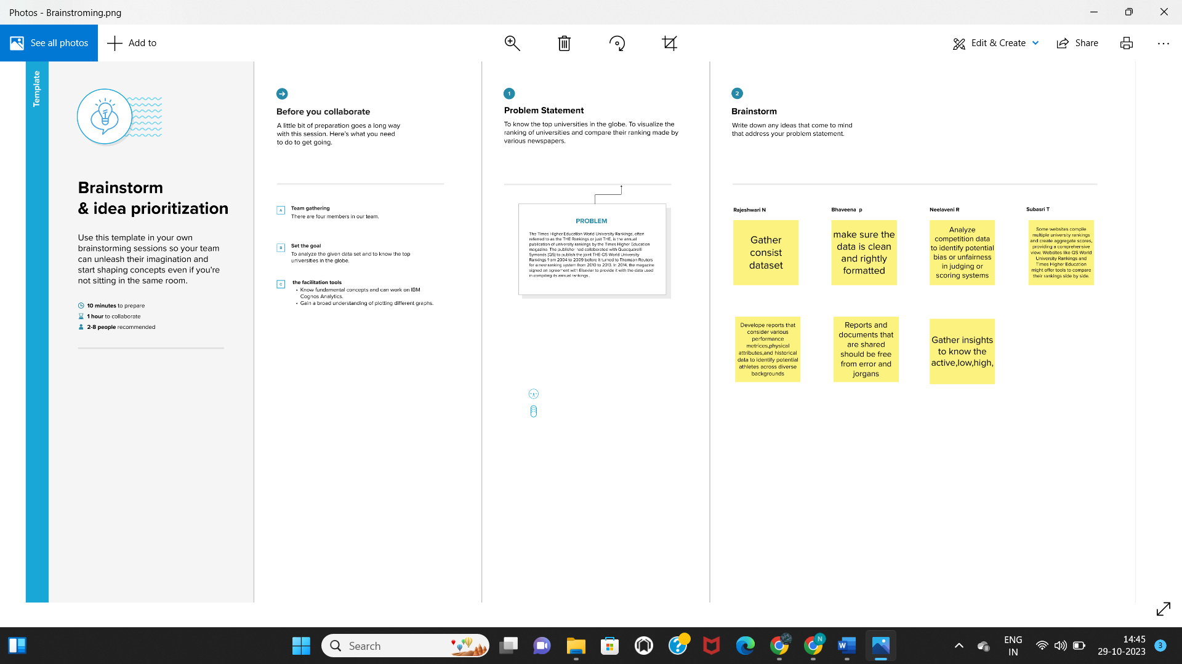

**Step-2: Brainstorm, Idea Listing and Grouping**

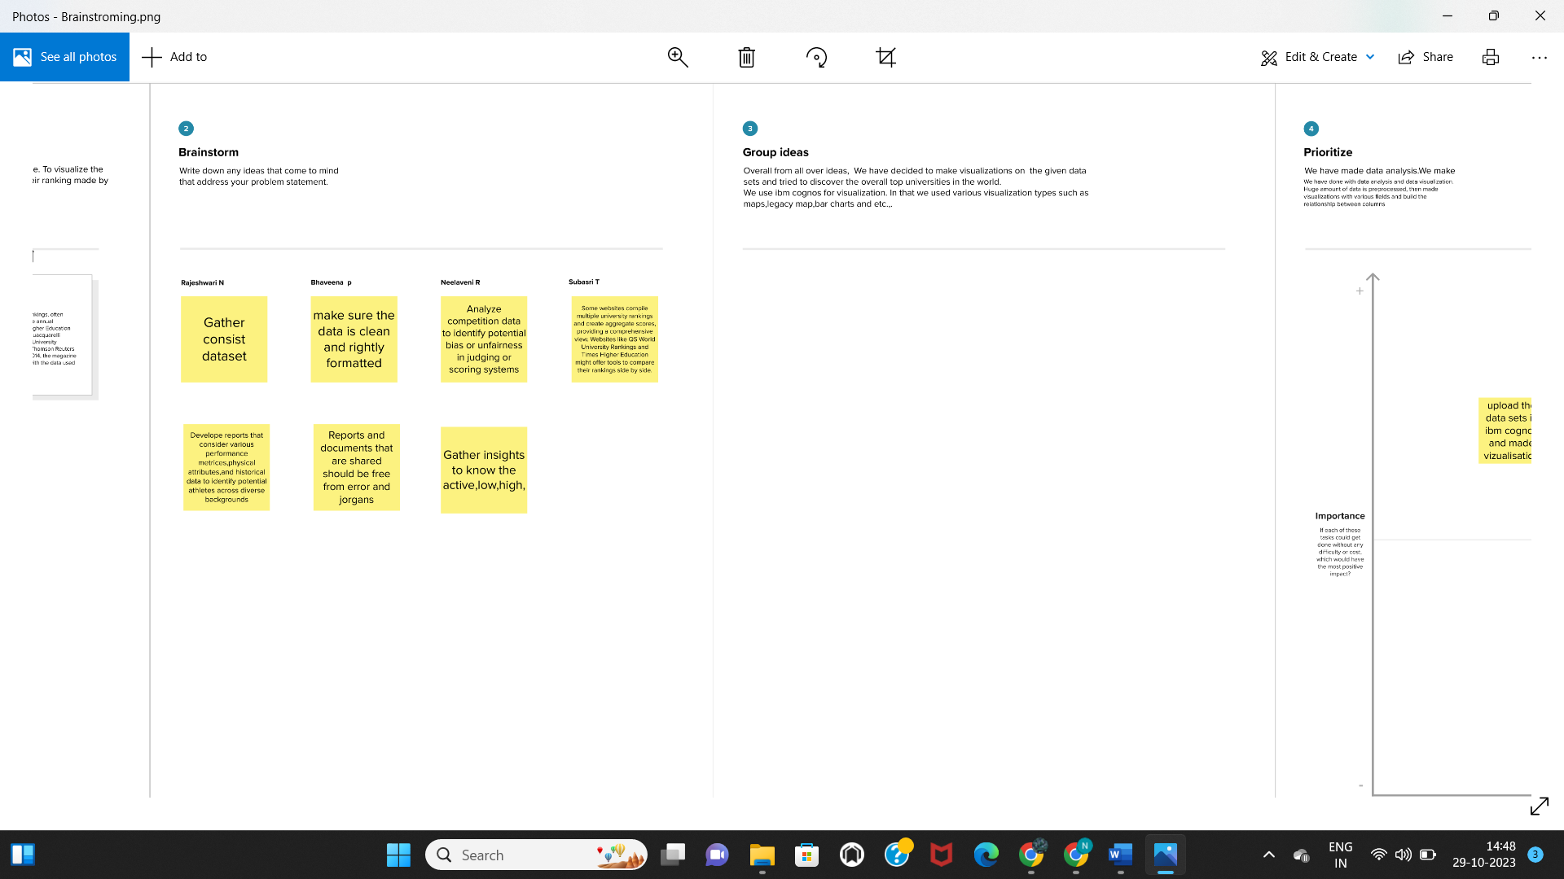

**Step-3: Idea Prioritization**

